Important Combinatorics formulas:

1. (n-1)C(r-1) + (n-1)Cr = nCr
2. (r)\*nCr = (n)\*(n-1)C(r-1)
3. nCr/(r+1) = (n+1)C(r+1)/(n+1)
4. For 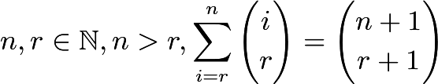. (Hockey stick identity)
5. What is C(k + 1 — j + r — l, k + 1 — j)